The Area VII Officer Selection Process

The Area Officer selection process is based upon the relevant competencies identified in the Effective Officer Study conducted in 2005 by the National FFA Organization. The competencies are evaluated in a number of different ways ranging from your performance on a written exam to your performance in an interview setting. As shown in the last section, the competency builders are the building blocks for the interview process. This section details the specific ways that each candidate’s skills will be evaluated. The selection process provides a method to carry out this important task. All the details are provided for your help in preparing. It may be cliché, but ask most any past Area officer – regardless of what you know about each round – there’s still something that’s more important to your success: Stay true to yourself!

The election process will be divided into two phases. Phase I will consist of three scored components. Phase I and Interview Portion of Phase II will be completed on the same day.
Phase I Components:
- Written Exam
- Writing Exercise
- Personal Interview Round I
Phase II Components:
- Round Robin Stakeholder Conversation interview
- Campaign speeches and voting (Saturday, May 13, 2023)
- Run-off speeches and voting (Saturday, May 13, 2023)

An election committee will complete the interview scores for all candidates. This committee will be composed of the eight current Area officers and six Agriculture Science teachers, one from each of the Area VII Districts. There will also be three non-scoring teachers to facilitate the process, record scores and manage the elections processes. The Districts will select the teacher representatives. The other teacher positions will be appointed by the Area VII Executive Committee.

At the end of Phase I, the scores will be tabulated according to the designated tabulation process. The top two scoring candidates from each District will advance to Phase II. Interviews for Phase II will be conducted on the same day. Then on Saturday, May 13th 2023, the two candidates representing each district will give their speeches at Area Convention.

The delegates to the Area VII FFA convention will have the opportunity to hear a three-minute speech from each of the 12 officer candidates followed by a thought question. The answer to the thought question is not timed.

Utilizing the scores from the exam and written essay (20%) and two interview rounds (30%) and combined with the votes from each District (50%), the Area Officer Team will be selected for a run-off vote. The top 6 officers will each deliver a 1-minute run-off speech to the delegates to seek to be the Area VII President. The 2 at large officers will not deliver the runoff speech.

The following explains each of the scored rounds in the process in detail.

Written Test:
Area officers must consistently demonstrate a command of key issues related to agriculture, FFA and the education system. While some of this knowledge may be demonstrated by asking quality questions and carrying on informed conversations rather than “knowing facts,” it is still important that officers come in with a base understanding of core issues and facts related to these three areas of knowledge. Thus, a written exam consisting of two portions – multiple choice questions and essay prompt – will be administered to allow candidates to demonstrate evidence of this desired knowledge set.

Multiple Choice Questions: All candidates will have 60 minutes to complete a written test comprised of 150 multiple-choice questions. The test shall follow the same format as the current senior division FFA quiz leadership career development event.

Competency Builders Evaluated:
3.1 Knowledge of the industry of agriculture and current issues
3.2 Knowledge of FFA and current issues

Writing Exercise:
All candidates will have 60 minutes to complete a written essay on a topic relevant to agriculture, FFA or the educational system. The purpose of the essay is focused on the candidate’s ability to convey knowledge and understanding in a different way than allowed through multiple choice questions. Each year a theme will be identified (agriculture, FFA or American education). The theme and a list of potential topics will be published for all candidates. Candidates are encouraged to understand each topic very well. However, the essay will also require candidates to demonstrate an understanding of how that particular topic relates to the other themes, not reflected in that particular year (i.e., if agriculture is the theme during the current year then the essay prompt will require candidates to demonstrate understanding of the topic as well as the relationship that topic shares with FFA and/or the American education system). Each of the writing essays will be reviewed by three independent adult judges to be appointed by the Area VII Executive Committee. These judges will review the essays on site and rate them on each of the competency builders identified for this portion of the essay. Scoring for each builder will be based upon a scale of one to five with five representing strong evidence the skill is present and one representing strong evidence the skill is not present.
2023 Essay Theme:
– FFA Current Events and Issues

2023 Potential Topics:
• Supervised Agriculture Experience (SAE)
• Member engagement
• Reflecting our local community (diversity/inclusion)
• FFA Membership (recruitment and retention)
• Advocating for FFA

Competency Builders Evaluated:
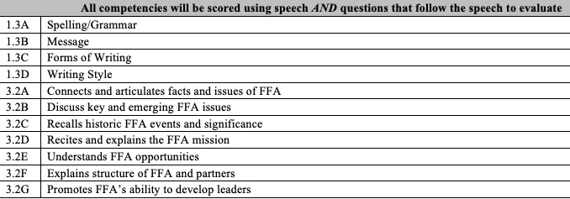

Personal Round I:
In this round, candidates will have ten minutes to “introduce” themselves to the 14 member election committee. In this one-on-fourteen format, candidates should capitalize on this time by making their first impression a lasting impression. Candidates can expect to answer three to six behavioral-based interview questions posed by the election committee and to expound on their goals, motivations and/or desire to be an Area officer. The following competency builders will potentially be evaluated by the election committee members using the 1 to 5 scale developed for each builder.

Competency Builders Evaluated during Personal Interview: Introduction
1.1A- Tone
1.1B- Attention (Eye Contact)
1.1C- Mannerisms
1.1D- Gestures
5.3B- Optimistic Attitude
5.3C Enjoyable Presence
5.4C- Communicates true self with tact
6.1D- Well Poised
6.3A- High Energy Level, Positive, and Maintains Stamina
6.1A- Desire to achieve in a fast-paced environment
6.1B- Willing to take risks and step outside comfort zone
6.1C- Considerably sticks to convictions/beliefs
6.2A- Supporting and Advancing FFA mission through words and actions
6.5A- Consistently engages in service opportunities***
6.5B- Demonstrates leadership in a service activity***
6.5C- Awareness of community needs
6.5D-Upolds Personal Philosophy Reflecting Service Attitude
7.1A- Communicates the Value of Being a Member and the opportunities available in FFA
***This can be service in OR outside the FFA***

Round Robin – Stakeholder Conversation:
The purpose of this interview is to evaluate the candidate’s demonstration of the effective officer competencies while carrying on a conversation regarding key issues related to a stakeholder. Stakeholders during this round may include: administrators, agriculture instructors, teacher educators, sponsors, media and parents. This round will occur in one 10-minute interview. The candidates will be evaluated simultaneously by the 14-member election committee. The stakeholder will not offer advice on the specific scores given to the candidates. The following competency builders will be evaluated by the election committee using the 1 to 5 scale developed for each builder.

Competency Builders Evaluated during Round Robin – Stakeholder Conversation
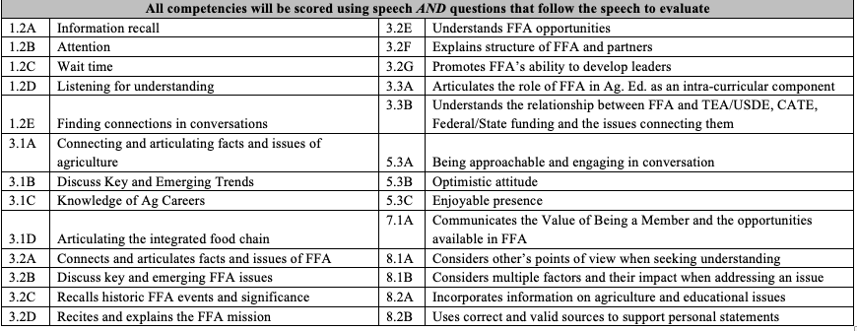

Expectations for all Rounds:
Candidates are expected to report at the scheduled meeting time. This ensures that all candidates are in place and ready to start on time. This early arrival provides the candidate committee the flexibility to start the next grouping early should they be operating ahead of schedule. In the event that a candidate is tardy to a round, the election superintendent and adult consultants will make and enforce a ruling.

Scheduling of Rounds:
The creation of the interview schedule is guided by the time requirements for each round. The order of the candidate interviews within each round is determined by a random order of drawing for assignment. In addition, “breaks” are scheduled between the groupings to provide the nominating committee members a chance to “stretch” and refresh themselves. The only modification of the random assignment process that is considered is when the candidates are scheduled to participate in other convention events such as public speaking. No consideration is given to FFA District, gender or ethnicity in the random assignment.

The Scoring System:
To facilitate the evaluation of the competencies throughout the rounds a scoring system is needed. This system is designed to ensure that the scores collected throughout the rounds ensure that the end score reflects how well a student did on the actual competencies, not just how they did in each round. This helps to ensure selection of the most qualified candidates for the job description outlined in section one the interviewing system is designed to screen for the eight effective officer competencies. This section details the scoring processes used throughout the rounds described in the last section.

The Scale for Each Competency Builder
The scale used to evaluate each of the competency builders is a 1--3--5 scale.
A score of “1” indicates “Strong Evidence the Skill/Attribute is not Present”
A score of “3” indicates “Some Evidence the Skill/Attribute is Present”
A score of “5” indicates “Strong Evidence the Skill/Attribute is Present”

This scale focuses students on searching for verifiable evidence of skills and attributes outlined in the competencies. To facilitate this detailed look-for, indicators will accompany each 1-3-5 rating for each competency builder.

Competency Index
It was determined that some of the competencies are more important to the officer selection process. Thus, the overall score should be constructed by allowing those competencies with were deemed most important to carry more weight. For example in the overall score used in the selection process candidate’s cumulative score for team player represents 10 percent whereas the candidate’s cumulative score for character represents 20 percent. The following index reflects each competency’s relative importance in the selection process:
1) Communication – 15%
2) Team Player – 10%
3) Areas of Knowledge – 5% (assessed also during the test and writing exercise)
4) Personal Organization – 10%
5) Character – 20%
6) Passion for Success – 15%
7) Influence – 15%
8) Critical Thinking – 10%
Score Calculations
The overall cumulative score is determined by a simple process. As shown in the previous section during each round particular competency builders will be evaluated using a 1-3-5 scale. The score recorded for each of these competency builders will be entered into the scoring system. The sum of the scores for each competency builder will be accumulated into an overall score for each of the competencies after each round. An average value is achieved by dividing the cumulative sum of all competency builders for one particular competency by the total number of data points collected on that competency builder in that round. At the conclusion of Phase I, all averages for each competency will be added together to determine the candidate’s overall competency score for this phase. The overall cumulative score for each of the eight competencies (a value between 1.0 and 5.0) will be multiplied by the weighting index shown above to determine the contribution that competency will make to the overall score (a value between 1.0 and 5.0 points). Once that has been determined that number will be multiplied by 20 to figure their score on a 100-point scale. The final number will be multiplied by .30 to determine the 30 percent total interview score. The numerical value that is the difference between the top indexed score and the number 30 shall be added to all of the following scores
Candidates will continue to contribute to their overall cumulative score through completion of Phase II. The final scoring calculation will be the addition of the score derived from the vote of delegates at the convention. The individual with the highest cumulative score after the run-off will be named the Area President. The individual with the second highest cumulative score after the run-off will be named the Area First Vice President. The 6 remaining officer positions will be determined by their respective score totals to fulfill the constitutional offices and for ceremonial purposes. These officers will be designated as “Vice Presidents” for their term of office.

